CYBERSECURITY & ETHICAL HACKING

SMARTBRIDGE EXTERNSHIP PROGRAM

Francin Samuel

20BCE2836

FILE AND DIRECTORY OPERATIONS

1. ls (list files and directories)



2.cd (change directory)

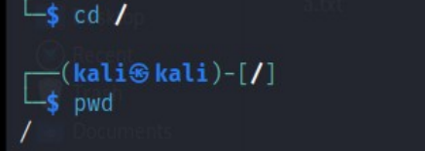

3.pwd (print working directory)



4.mkdir(make directory)





5.touch (create an empty file)



6.cp (copy files and directories)





7.mv (move or rename files and directories)



8.rm (remove files and directories)



9.find (find for files and directories)

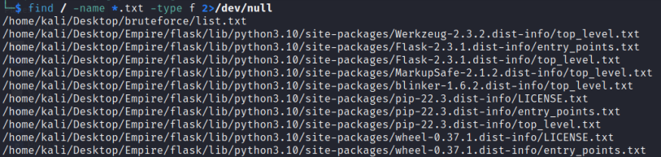

FILE VIEWING AND EDITING

1.cat (concatenate and display content)

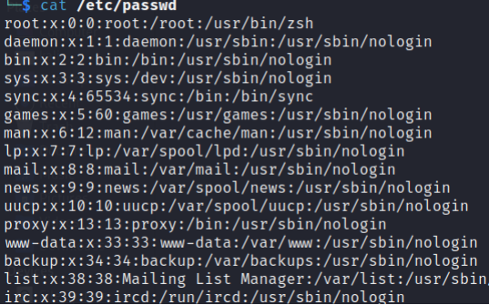

2.less (view file content with pagination) less /etc/passwd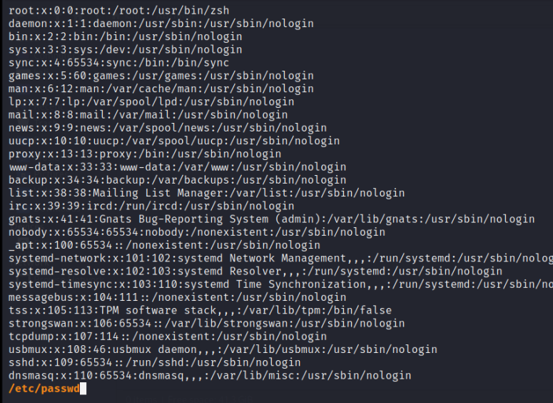

3.head (display the beginning of a file) 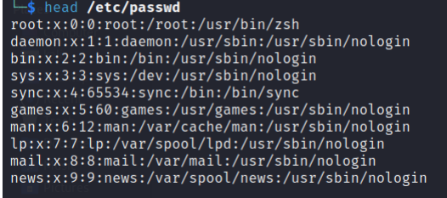

4.tail (display the end of a file) 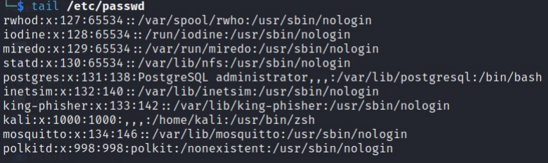5.nano (text editor for creating and editing files)



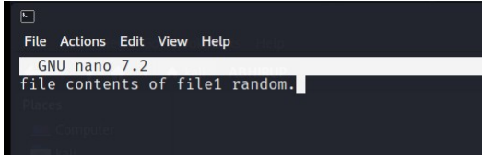

6.vi/vim (powerful text editor for experienced users)

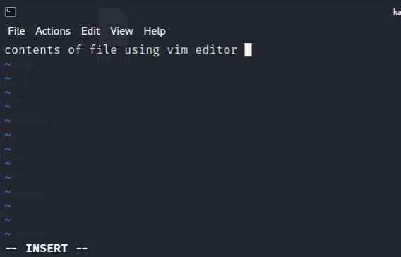

FILE PERMISSIONS

1.chmod (change file permissions)

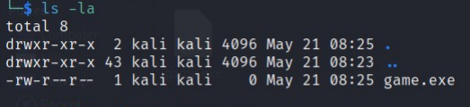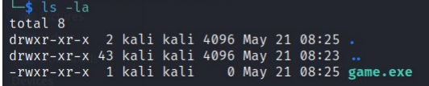

2.chown(change file owner)

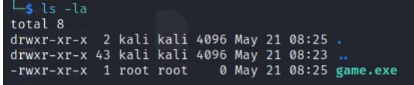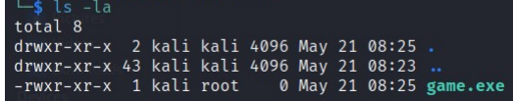

3.chgrp (change file group)

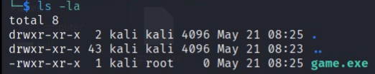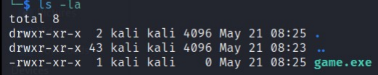

FILE COMPRESSION AND ARCHIVING

1. tar (archive files)

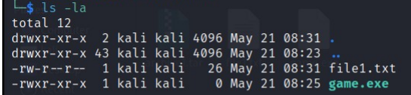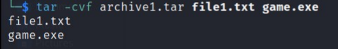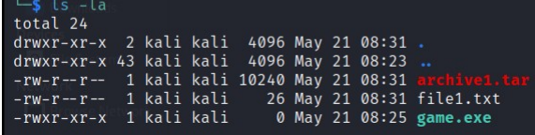

2.gzip (compress files)

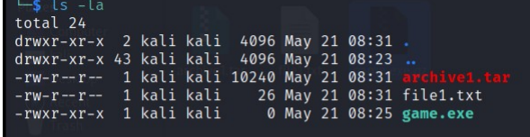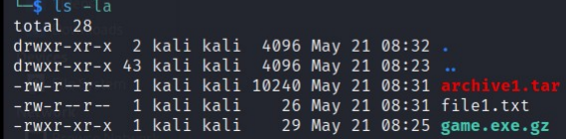

3.unzip (extract files from zip archive) 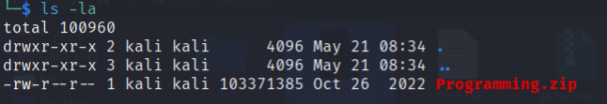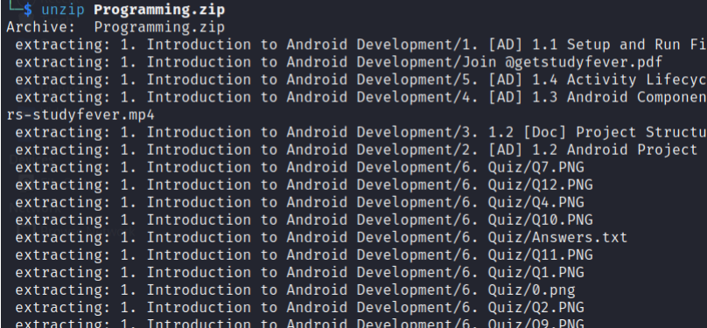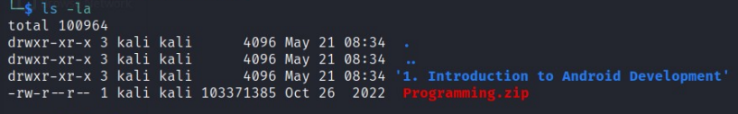

PROCESS MANAGEMENT  
 1.ps (list running processes)

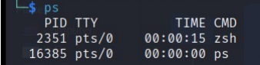

2.top: Display real-time system information and processes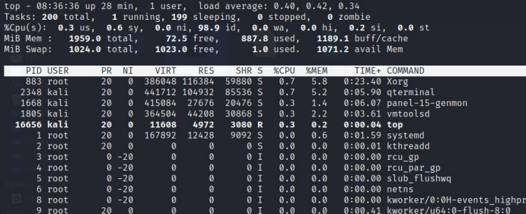

3.kill (terminate processes)

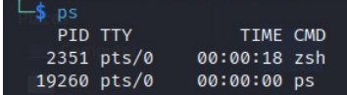

4.bg (run processes in background)

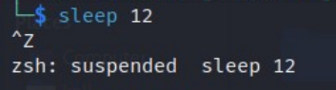 

SYSTEM INFORMATION

1. uname: Print system information



1. df: Display disk space usage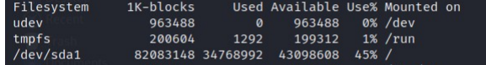
2. free: Display memory usage

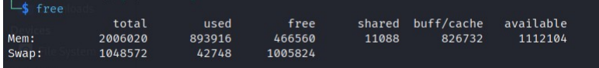

1. uptime: Show system uptime



1. who: Display logged-in users

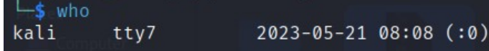

NETWORKING

1. ifconfig: Configure network interface

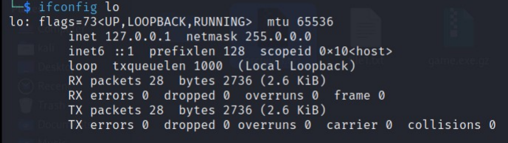

2. ping: Send ICMP echo requests to a network host



3. ssh: Securely connect to a remote system



4. scp: Securely copy files between systems

5. wget: Download files from the web

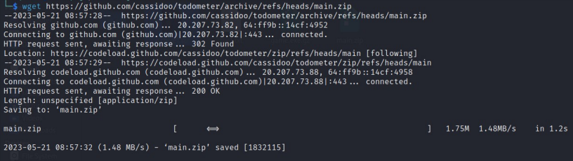

SYSTEM ADMINISTRATION

1. sudo: Execute commands with superuser privilege

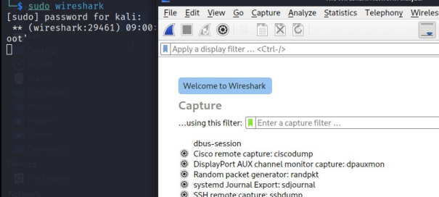

2. apt-get: Package management for Debian-based distributions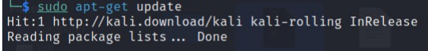

5. crontab: Schedule recurring tasksv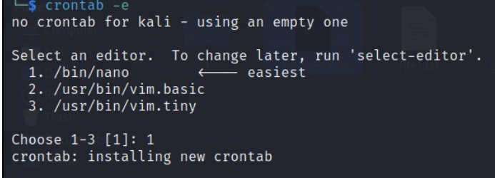

cronjob to ping localhost everyday with 1 packet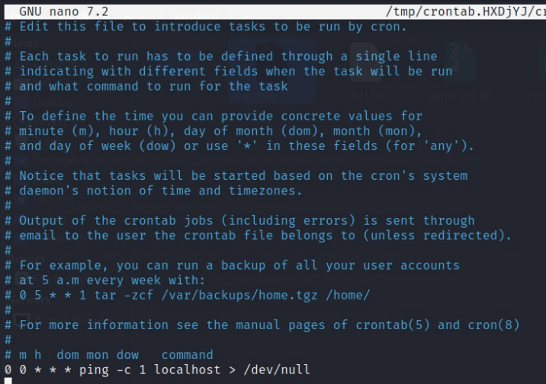

7. passwd: Change user password

